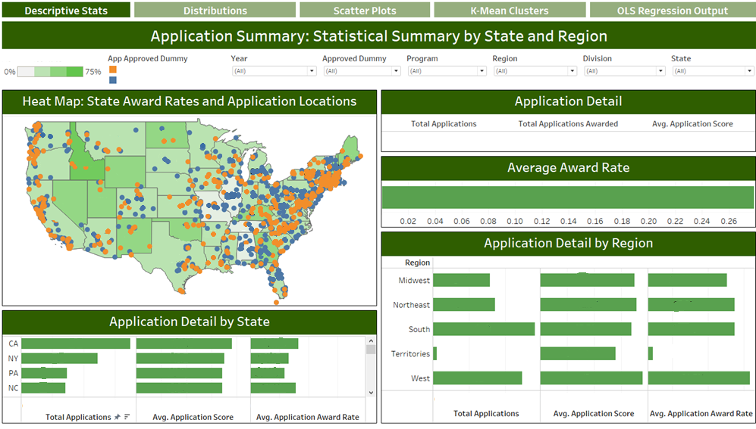**Certain Information Redacted**

